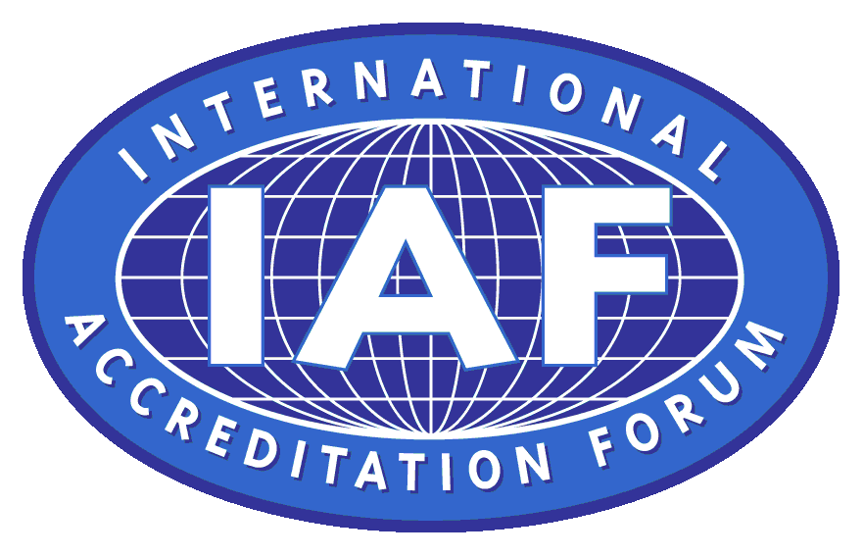
国际标准化组织 国际认可论坛
日期：2010年12月1日
ISO 9001审核实践组指南
对待咨询师的指南
1. 引言
在ISO9001中并没有要求组织在实施质量管理体系时使用咨询师，但它是被认可的，许多组织都选择这样做。人们还认识到，咨询师在认证审核期间很可能会到场，在审核过程中他们可能会在不同程度上参与。
在某些情况下，组织可能会请求他们的咨询师在认证机构审核期间到场。咨询师会以何种方式参与将取决于审核组对实现审核目的可能是有利还是不利的判断。本文件为审核员如何处理可能出现的情况提供了一些实用的指导。
注：ISO 10019《对质量管理体系咨询和使用其服务的选择指南》中提供了可能是最好地使用质量管理体系咨询师的方法，为帮助组织实现其目标提供了有益的指导。
如果审核组了解到咨询师还有“管理者代表“的作用（按照ISO9001，条款5.5.2），那么审核员应该能够获得咨询师作为管理者代表的角色和履行条款5.5.2职责要求的适当的客观证据。
2. 对第三方审核员的指南
- 重要的是要认识到为了认证，认证机构与其委托人（“组织”）之间的关系是合同关系，咨询师并没有直接参与。
- 请记住，现在是对组织的管理体系的实施进行审核，而不是对咨询师！
- 如果有限制或者对使用个别的咨询师持保留态度，审核组应该在对组织实施审核之前与受审核方进行沟通并达成一致。
- 审核组长应当在首次会议上明确指出，咨询师的作用与观察员类似，咨询师不得
试图影响或干预审核过程或审核结果。在某些情况下，审核员可能不容易理解受审核方所使用的专业术语，此时由咨询师协助受审核方向审核员解释这样的问题可能是有益的。不过此时无论是审核时间管理，还是审核目的这两者都不应该被认为允许妥协。
免责声明
这篇文章未经过由国际标准化组织（ISO）、ISO第176技术委员会或国际认可论坛（IAF）组织的认可过程。
文中所包含的信息可用于教育和交流的目的。
（HXQC 宋治民编译，仅供参考）
2011.02.09
附英文原稿:

Date: 1 December 2010

ISO 9001 Auditing Practices Group

Draft Guidance on:
How to deal with consultants
1. Introduction.
There is no requirement in ISO 9001 for an organization to use a consultant when implementing its quality management system, but it is recognized that many organizations choose to do so. It is also recognized that consultants are likely to be present during certification audits, and that they may get involved to different extents in the audit process.
In some cases, the organization may request their consultant to be present during audits by the certification body. Depending on the way in which this is managed by the audit team, the involvement of a consultant can be beneficial or detrimental to achieving the audit objectives. This document provides some practical guidance to auditors on how to deal with some of the situations that might arise.
Note: ISO 10019 “Guidelines for the selection of quality management system consultants and use of their services” provides useful guidance about the ways in which a quality management system consultant might best be used in order to help an organization to achieve its objectives.
In case it comes to the knowledge of the audit team that a consultant also has the role of the "Management Representative" (as per ISO 9001, clause 5.5.2) then the auditors should be able to obtain appropriate objective evidence of the consultant functioning as the Management Representative in terms of the roles and responsibilities required by clause 5.5.2.
2 Guidance for Third Party Auditors
It is important to recognize that the contractual relationship for certification is between the certification body and its client (“the organization”), with no direct involvement of the consultant.
Remember that it is the implementation of organization’s Management System that is being audited, not the consultant!
If there are restrictions or reservations about the use of a specific consultant, this should be communicated and agreed with the organization prior to the audit.
It should be made clear by the audit team leader during the opening meeting that the role of the consultant is similar to that of an observer and that the consultant should not try to influence or interfere in the audit process or in the outcome of the audit. In certain circumstances the auditee may not be able to understand the technical jargon used by the auditor and it may be beneficial to have the consultant assist the auditee to understand the issue. However, this should not be allowed to compromise either the time management for the audit, or the audit objectives
Disclaimer
This paper has not been subject to an endorsement process by the International Organization for Standardization (ISO), ISO Technical Committee 176, or the International Accreditation Forum (IAF).
The information contained within it is available for educational and communication purposes.

